Backward Planning Template
“Start Where You Want to End”

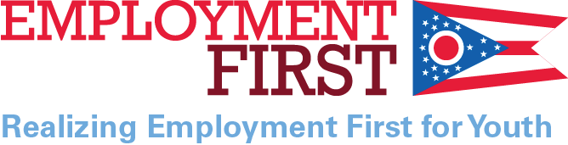
Birthdate: | Time Span of this plan:  From To | Graduation Year | Team Coordinator

Adult Employment Outcome or Goal  As an adult, I plan to: | Adult Education /Training Outcome or Goal  As an adult, I plan to: | Adult Independent / Community Living Outcome or Goal. As an adult, I plan to:

Current Assessment Related to Milestone  Date: | Steps to Reach Milestone  Target Year ______ | Steps to Reach Milestone  Target Year ______ | Steps to Reach Milestone  Target Year ______ | Steps to Reach Milestone  Target Year ______ | Steps to Reach Milestone  Target Year ______ | Milestone  To Be Achieved By:  ____________

